Multi Inverter air conditioner

Service Manual

Models
Wall-mounted type：
TSVH09HEI2N24I454
TSVH12HEI2N24I454
TSVH18HEI2N24I454
BAH09HEI2N24I454
BAH12HEI2N24I454
OUTDOOR UNIT：
TV2H18FM22X454
TV3H27FM22X454
TV4H36FM21X454
TV5H42FM20X454
BAM3H27F22X454
BAM4H36F21X454

CONTENTS
1.Important Notice 3
2.Refrigeration cycle diagram 4
3.Operation details 5
4.Wiring diagram 12
5.Precaution 15
6.Names of parts 18
7.Installation manual 21
8.Trouble shooting 27
9.THERMISTOR CHARACTERISTICS 48

1.Important Notice

This service manual is intended for use by individuals possessing adequate backgrounds of electrical, electronic and mechanical experience. Any attempt to repair the appliance may result in personal injury and property damage. The manufacturer or seller cannot be responsible for the interpretation of this information, nor can it assume any liability in connection with its use.
The information, specifications and parameter are subject to change due to technical modification or improvement without any prior notice. The accurate specifications are presented on the nameplate label.

How to order spare parts
To have your order filled promptly and correctly, please furnish the following information:
- Model No. with Indoor or Outdoor
- No. in the Explosion View
- Part Name
- The quantity you ordered

2.Refrigeration cycle diagram
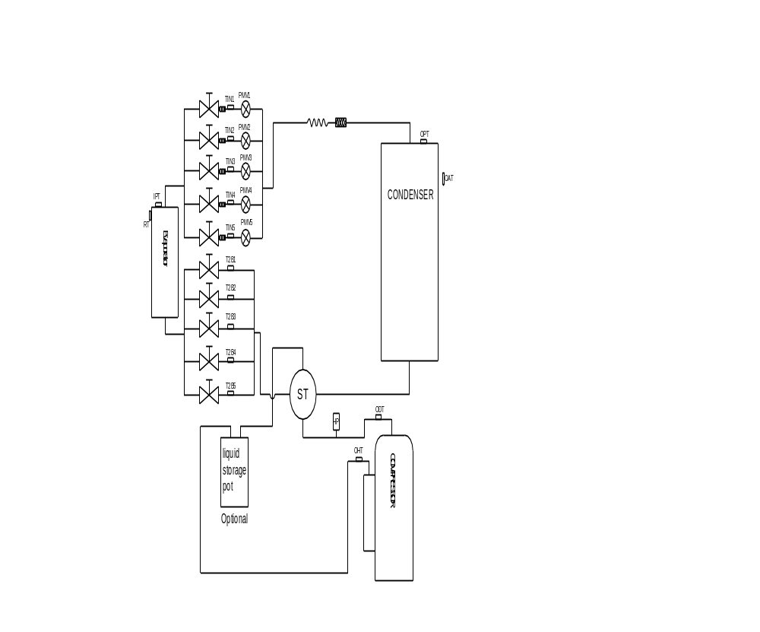

3.Operation details
Electronic Controller
- Safety Protection
  - Time Delay for Safety protection
- 3 minutes delay for compressor ---The compressor is ceased for 3minutes before restarting to balance the pressure in the refrigeration cycle in order to protect the compressor.
- 150 seconds delay for 4-way valve---The 4-way valve will be ceased for 150 seconds late after compressor to prevent the refrigerant-gas abnormal noise when the HEATING operation is OFF or switch to the other operation mode.
  - Discharge temperature protection
There is a temperature sensor on discharge pipe, when temperature on discharge pipe exceeded the limit 115℃, system control will shut down the compressor and the display board will show the error code.
  - Lower voltage protection
When AC voltage <160V, DC voltage<170V, unit will be shut down for protection and recover while the AC voltage ˃170 V, DC voltage ˃190V.
  - Over voltage protection
When AC voltage ˃ 275V, DC voltage ˃400V unit will be shut down and recover while AC voltage<255V, DC voltage<390 V.
  - Over current protection
When the current of outdoor unit is overload, controller will drop the operation frequency or shut down the unit immediately and show error code.
  - Condenser temperature protection
When condenser temperature≥ 65℃ and keep 10s, the air conditioner will shut down, and show error code, and recover while condenser temperature<52℃ and the compressor stop for 3minutes.
  - IPM module protection
IPM module has high temperature & over current protection itself, if there is signal feedback to IPM, the outdoor unit will shut down, LED on outdoor PCB will show the error code.
  - Evaporator freeze protection.
When evaporator temperature<2℃, the controller will drop compressor operate frequency.
When evaporator temperature<0℃ and keep 1 minute, the expand valve of the unit will stop.
When all of the operating unit enter freeze protect, the compressor will stop and recover while evaporator temperature and stop for 3 minutes.

“Feel” Mode Operation
1. The set temperature can be adjusted from 16-31℃ on auto mode, the operation of fan speed and vane position according to preset.
2. Operation
When unit set to auto mode, it will work on cooling, heating or fan mode totally according to Δt --the temperature difference between RT and ST shown as table:

Mode | Δt=RT-ST
COOLING | Δt >1℃
FAN | -1℃≤Δt≤ 1℃
HEATING | Δt <-1℃

3. “COOLING” Mode Operation
- Compressor frequency control
According to difference room temperature and set temperature (δt = RT-ST), running frequency of compressor is controlled by electronic controller. When room temperature is much higher than set temperature, the compressor will start at a high frequency, and as room temperature goes down, the compressor running frequency will go down. When room temperature is lower than set temperature, the compressor will run at very low frequency. In general, unit will change its running frequency according to δt to make room temperature closing to set temperature.
- Outdoor temperature affects running frequency of the compressor
Outdoor temperature affect compressor’s running frequency. Difference inlet temperature of outdoor unit is adapted by difference compressor running frequency. While outdoor temperature is about 30℃, the compressor will run in high frequency.
If unit run in “cooling” mode and outdoor temperature is less than -2℃,the controller will shut down compressor and show error code, while the ambient temperature is over 1℃, the compressor will run automatically.
- Auto fan control in cooling mode
In cooling mode (include cooling in “Feel” mode), fan speed is determined by δt, as the following diagram:
δt come down

δt come up

℃
4.0
3.0
1.5
1.0
High fan

Min fan

Low fan

4.“DRY” Mode Operation
- The system for DRY operation used the same refrigerant circle as the cooling one.
- When the system operates in DRY mode, at first it operates in cooling mode, the set temperature (ST) is “RT-2℃”. After that, the system will operate in cooling mode with lowest fan speed. During the course of this operation, you can’t use remote controller to adjust the fan speed but you can control the vane direction.
- In the dry mode, when RT≤12℃, the compressor will stop and operates again at RT≥14℃.

5. “HEATING” Mode Operation (available for Heat Pump only)
- Frequency control
Same as the frequency control in cooing mode, the running frequency of compressor is controlled by controller. Unit change its running frequency according to δt to make the room temperature closing to the set temperature.
- Indoor fan motor control
- Cold Air Prevention Control
- The function is intended to prevent cold air from being discharged when heating mode selected or while in defrosting.
- The indoor fan speed will be controlled as following.
Indoor pipe Temperature

33℃
Breeze
Temperature up
Temperature down
Setting
Low fan
Stop
37℃
33℃
25℃
25℃
20℃

- In heating operation, if air conditioner turn off, the indoor fan motor will run most for 30 seconds since the stop of compressor.
- Auto fan control (heating)
In heating mode (include in “feel” mode) , fan speed is determined by δt as the following:

℃
RT-ST

δt come up

δt come down

High fan

4.0
3.0

Min fan

1.5

1.0
Low fan

- 4-way valve control
In heating mode, 4-way valve will power on ahead of compressor for 8 seconds, and cut off for 2 minutes later than compressor. 4-way valve will not power off unless the machine to be switched off, mode changed or on the process of defrosting.
ON
ON
4-WAY valve
OFF
Outdoor fan motor
ON
OFF
OFF
Compressor
30S
3S
120S
5S
- Outdoor fan motor control
In heating mode, the outdoor fan motor will power on ahead of compressor 5 seconds, and cut off for 30seconds later than compressor.
ON
Outdoor fan motor
OFF
Compressor
OFF
ON
30S
5S

- Defrosting
Defrosting is controlled by the microprocessor.
When the unit operate 30 minutes accumulated and the compressor operation more than 3 minutes continuously, one of the following conditions is satisfied, unit comes into defrosting:
- When FrostDeg ≥ -5℃, and OPT ≤ -5℃, the .2 times defrosting interval time is 45 minutes.
- When -10℃≤ FrostDeg < -5℃, and OPT < FrostDeg , the .2 times defrosting interval time is 45 minutes.
- When -13℃≤ FrostDeg < -10℃, and OPT < FrostDeg , the .2 times defrosting interval time is 45 minutes.
- When -15℃≤ FrostDeg < -13℃, and OPT < FrostDeg , the .2 times defrosting interval time is 65 minutes.
- When -15℃≤ FrostDeg < -10℃, and OPT < FrostDeg , the .2 times defrosting interval time is 75 minutes.
- When FrostDeg < -15℃, and OPT < -15℃, the .2 times defrosting interval time is 75 minutes.
FrostDeg = C*OAT-α
OAT: Outdoor environment temperature.
When OAT< 0℃, C=0.8, when OAT≥ 0℃, C=0.6
α=8
Before the air con comes into defrosting, compressor running frequency drop down to a lower frequency firstly, then the compressor shuts down.
In defrosting, all protection function are available.
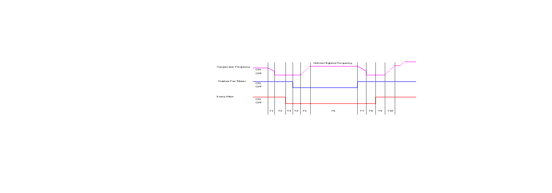
T | T1 | T2 | T3 | T4 | T5 | T6 | T7 | T8 | T9 | T10
Times | Drop frequency or stop | 50s | 5s | 5s | Rise frequency | 2-11Min | Stop Defrost | 50s | 10s | Rise frequency

In defrosting, LED showing by winking.
No matter what AC come into or out of defrosting, indoor fan motor speed is the same as Cold Air Prevention Control.
While one of the following conditions is satisfied, unit comes out of defrosting and shifts to
heating mode:
  - Outdoor coil Temperature (OPT) >5℃ and keeps 30 seconds.
  - Outdoor coil Temperature (OPT) >10℃ and keeps 2 seconds.
  - Continue 11minutes defrost Operation.
(5) Indoor exchanger overheat protection
When Indoor exchanger Temperature (IPT) is higher than 54℃ , unit comes into indoor exchanger overheat protection. The compressor drops its frequency.
If IPT≥65℃ and keep for 30 seconds, control system shut down compressor, and recover while IPT drop less than 52℃.

“SLEEP” mode
When the SLEEP button is pressed, the AC operates as following:
- The indoor fan speed is set at low speed, the power lamp and the sleep lamp is on, the display of temperature will close after 30 seconds.
- When selecting COOLING/DRY operation with SLEEP mode, the set temperature will be raised by 1℃ 1 hour later and by 2℃ 2 hour later, after 3 hours, the set temperature will be raise by 3℃ and keeps 2hours. And then the temperature is Set+2℃, after 1 hour, the temperature is set temperature and keep.
- When selecting HEATING operation with SLEEP mode, the set temperature will be dropped by 1℃1 hour later and 2℃ 2 hours later, after 3 hours, the set temperature will be dropped by 3℃ and keep 2 hours. And then the temperature is Set-2℃, after 1 hour, the temperature is set temperature and keep.

EMERGENCY Operation
When the EMERGENCY Operation switch is pressed, “Beep” a short sound, COOLING mode is selected, two short sound the HEATING mode selected, and a long sound the unit off of 3s.
During the unit operation in emergency operation, when the unit receive the signal of remote controller, the unit will operates by remote.
When the remote controller missing, failed or the batteries run down, press the EMERGENCY Operation switch on front of the indoor unit for function test.
NOTE: Do not press the EMERGEMCY Operation switch during normal operation.

AUTO-RESTART Function (Option)
While air conditioner is operating in one mode, all of its operation data, such as working mode, preset temperature etc. would be memorized into IC by main PCB. If power supply cut off due to reasons and recover again, the AUTO-RESTART function will set synchronously and the air conditioner would work at the same mode as before.
Auto-restart Pre-setting (optional):
If Auto-restart function is needed, follow the steps below to activate this function:
- Pulling the air-con's plug out of socket.
- Pressing and holding the Emergency button (ON/OFF) on the indoor, then insert the plug into the socket again.
- Keep pressing the Emergency button for more than 10 seconds until three short beeps heard, the Auto-restart function been activated.
- When the unit in operation, press the timer button 10 times in 8s, the Auto-restart function will be active，if the Auto-restart is active, the Auto-restart off.
- Water pump control(cassette and duct type)
When the unit operates in cool or dry mode, the water pump operates, once the compressor off or change to other mode, the water pump stop after 10 minutes.
Anytime, when the unit check the water full, the water pump operates, the unit stop and display the water full code. When full water protection is eliminated, the pump will maintain for 10 minutes and then turn off
When check the water pump switch open for 8 seconds continuous, enter water full protection, and check the water pump switch on for 180 seconds continuous, the water full protection exit.

Protection and Failure Display
- When protection display is available, controller will show error code, digital LED shows error code and setting temperature by turns.
- If there is more than one failure, it will show error codes according to the error list sequence.
- To insure the signal communication of indoor and outdoor unit, any failure code relates to outdoor unit will remain display for 2 minutes maximum after it’s recovered.
- Among all the failure codes, sensor failure can be recovery automatically once it comes normal.

Failure code
Code | Reason | Remark
E0 | IDU & ODU Communication failure | The IDU & ODU wiring connection correct?
E1 | IDU Room Temperature sensor failure.（IDU RT failure） | IDU sensor and PCB.
E2 | IDU Coil temperature sensor failure.（IDU IPT failure） | IDU sensor and PCB.
E3 | ODU Coil temperature sensor failure. (OPT) | ODU coil sensor and ODU PCB
E4 | AC Cooling system abnormal | Gas leakage? 2-way or 3-way valve blocked etc.
E5 | IDU/ODU mismatched failure (specially performance test on the production line) | /
E6 | IDU PG Fan motor / DC fan motor works abnormal（IDU failure） | Fan motor, fan blade and PCB.
E7 | ODU Ambient Temperature sensor failure | ODU ambient sensor and ODU PCB.
E8 | ODU Discharge Temperature sensor failure. | ODU discharge sensor and ODU PCB.
E9 | IPM / Compressor driving control abnormal. | ODU PCB , compressor, etc.
EA | ODU Current Test circuit failure | ODU PCB broken?
Eb | The Communication abnormal of Main PCB and Display board（IDU failure） | Display board and main PCB.
EE | ODU EEPROM failure. | - ODU PCB broken?  - Try to re-power on AC unit.
EF | ODU DC fan motor failure. | Fan motor, ODU PCB.
EU | ODU Voltage test circuit abnormal. | ODU PCB.
d3 | Water full protection(water pump fail) | Please check the water pump.
P0 | IPM module protection. | ODU PCB
P1 | Over / under voltage protection. | - ODU PCB broken?  - Power supply abnormal?
P2 | Over current protection. | - ODU PCB broken?  - Power supply abnormal?
P4 | ODU Discharge pipe Over temperature protection. | Please check the troubleshooting for detail.
P5 | Sub-cooling protection on Cooling mode. | Please check the troubleshooting for detail.
P6 | Overheating protection on Cooling mode. | Please check the troubleshooting for detail.
P7 | Overheating protection on Heating mode. | Please check the troubleshooting for detail.
P8 | Outdoor Over temperature/Under temperature protection. | Please check the troubleshooting for detail.
P9 | Compressor driving protection (Load abnormal). | Please check the troubleshooting for detail.
PA | Mode conflict. | Please check the mode set.
F0 | Infrared Customer feeling test sensor failure. （IDU failure） | Querying by press remote controller
F1 | Electric Power test module failure. （IDU failure） | Querying by press remote controller
F2 | Discharge temperature sensor failure PROTECTION. | Please check the troubleshooting for detail.
F3 | ODU coil temperature failure PROTECTION.. | Please check the troubleshooting for detail.
F4 | Cooling system gas flow abnormal PROTECTION.. | Please check the troubleshooting for detail.
F5 | PFC PROTECTION | Please check the troubleshooting for detail.
F6 | The Compressor lack of phase / Anti-phase PROTECTION. | Please check the troubleshooting for detail.
F7 | IPM Module temperature PROTECTION | Please check the troubleshooting for detail.
F8 | 4-Way Value reversing abnormal.. | Please check the troubleshooting for detail.
F9 | The module temperature test circuit failure. | ODU PCB
FA | The compressor Phase-current test circuit failure. | ODU PCB
Fb | Limiting/Reducing frequency for Over load protection on Cooling/Heating mode. | Querying by press remote controller
FC | Limiting/Reducing frequency for High power consumption protection. | Querying by press remote controller
FE | Limiting/Reducing frequency for Module current protection ( phase current of compressor). | Querying by press remote controller
FF | Limiting/Reducing frequency for Module temperature protection. | Querying by press remote controller
FH | Limiting/Reducing frequency for Compressor driving protection. | Querying by press remote controller
FP | Limiting/Reducing frequency for anti-condensation protection.. | Querying by press remote controller
FU | Limiting/Reducing frequency for anti-frost protection. | Querying by press remote controller
Fj | Limiting/Reducing frequency for Discharge over temperature protection. | Querying by press remote controller
Fn | Limiting/Reducing frequency for ODU AC Current protection. | Querying by press remote controller
Fy | Gas leakage protection | Please check the troubleshooting for detail.
H1 | High pressure protection | Please check the press valve
H2 | Low pressure protection | Please check the press valve
bf | TVOC sensor failure（IDU failure, optional） | Querying by press remote controller
bc | PM2.5 sensor failure（IDU failure, optional） | Querying by press remote controller
bj | Humidity sensor failure. （IDU failure） | Querying by press remote controller
Note: Remote controller FAILURE CODE Querying function
As shown in the failure codes, some of the codes (Fb~bj) need to press remote control for inspection.
While unit on operation, press the ECO button 8 times with 8 seconds, the buzzer BIBI 2 times, you can inspect the special failure code as Fb ~Fn, bj etc.

4.Wiring diagram
Wall-mounted type:（9K,12K,18K）（800T，900T，1080T）
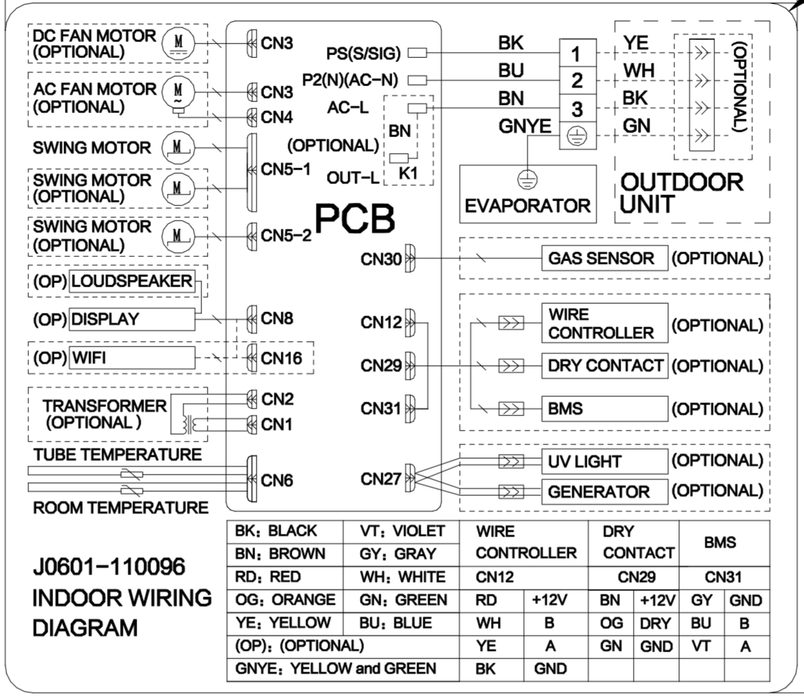

OUTDOOR UNIT：
ONE TO 2 TYPE: TFM2-18CHD/(I)(E/6)-t(UL) （18K）
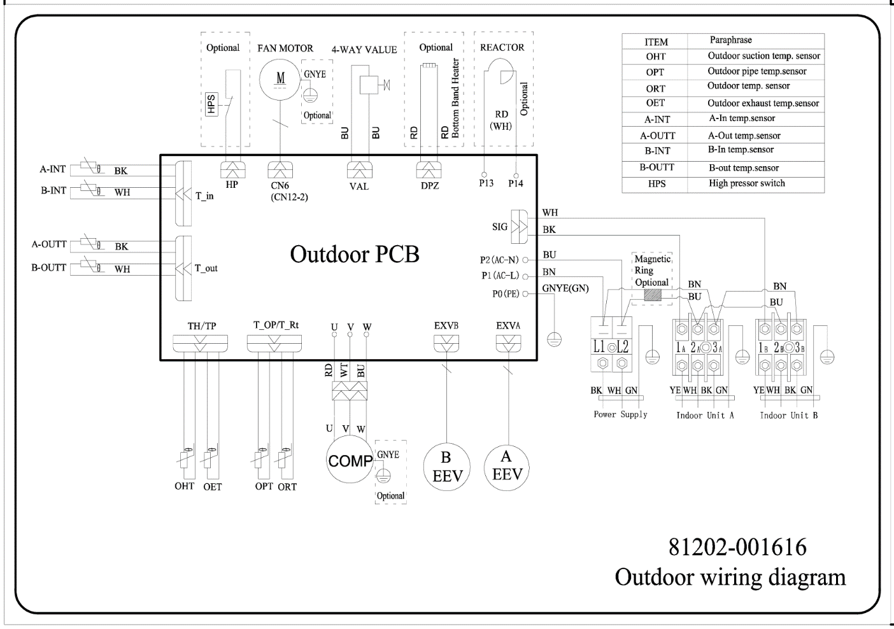

ONE TO 3 TYPE: TFM3-27CHD/(I)(E/6)-t(UL) （27K）
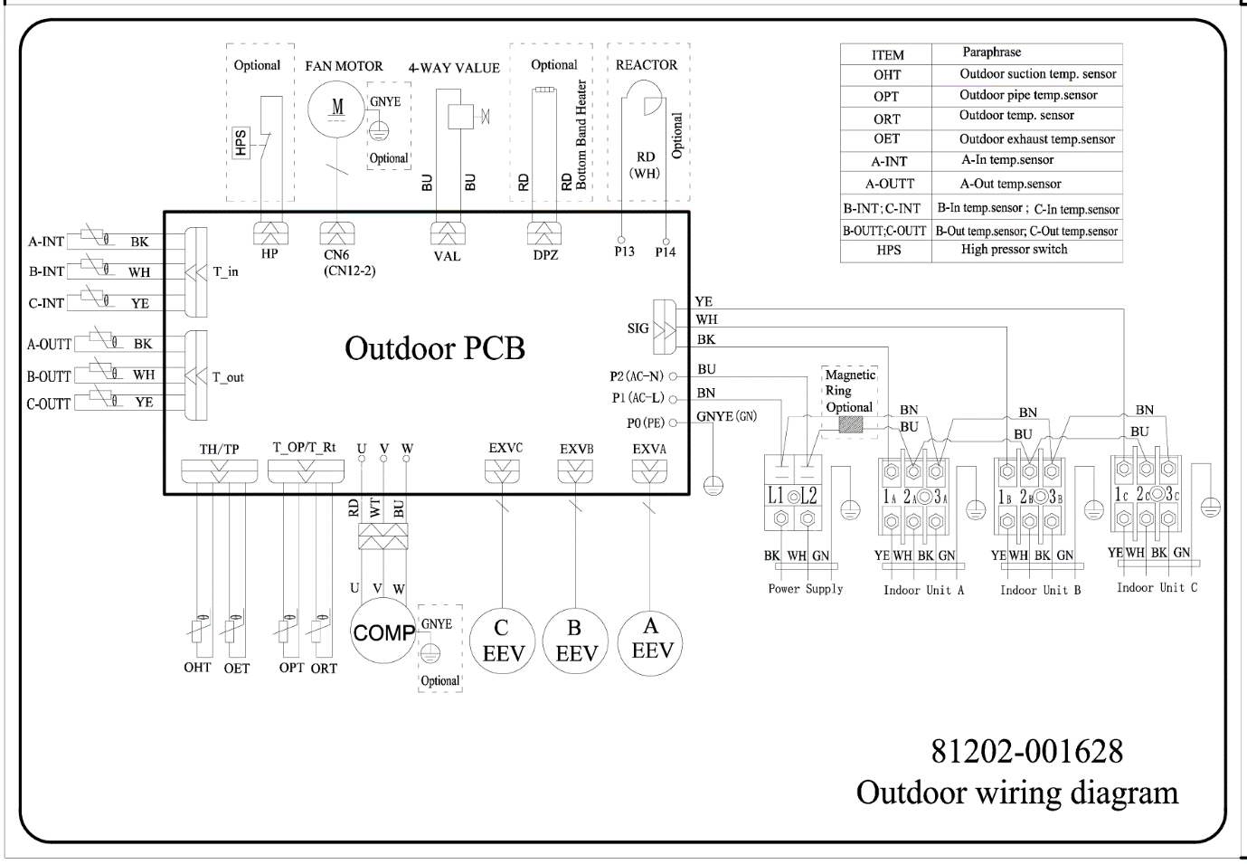

ONE TO 4 TYPE: TFM4-36CHD/(I)(E/6)-t （36K）
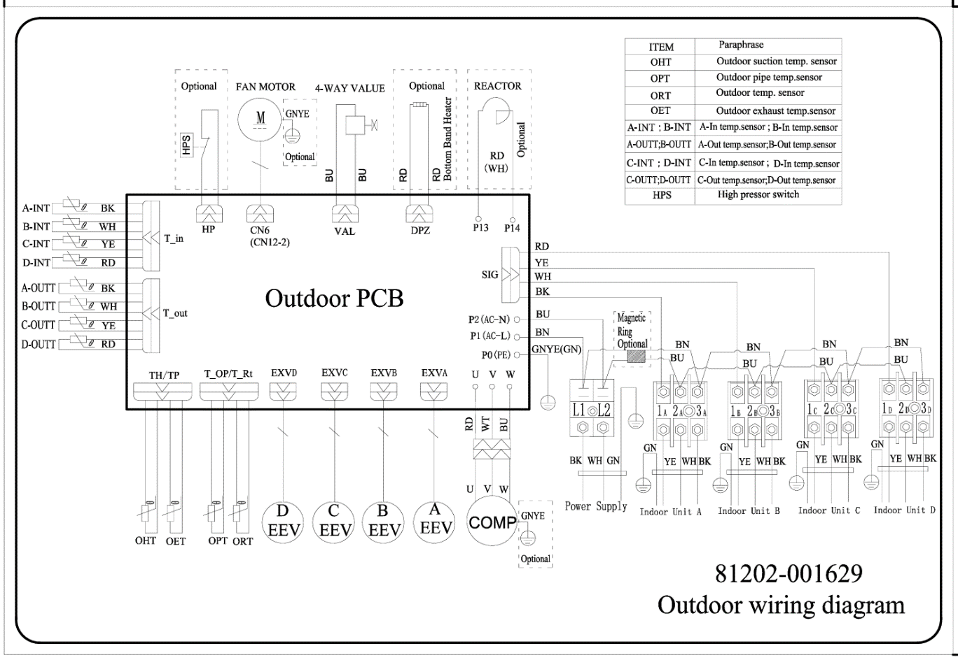

ONE TO 5 TYPE: TFM5-42CHD/(I)(E/6)-t （42K）
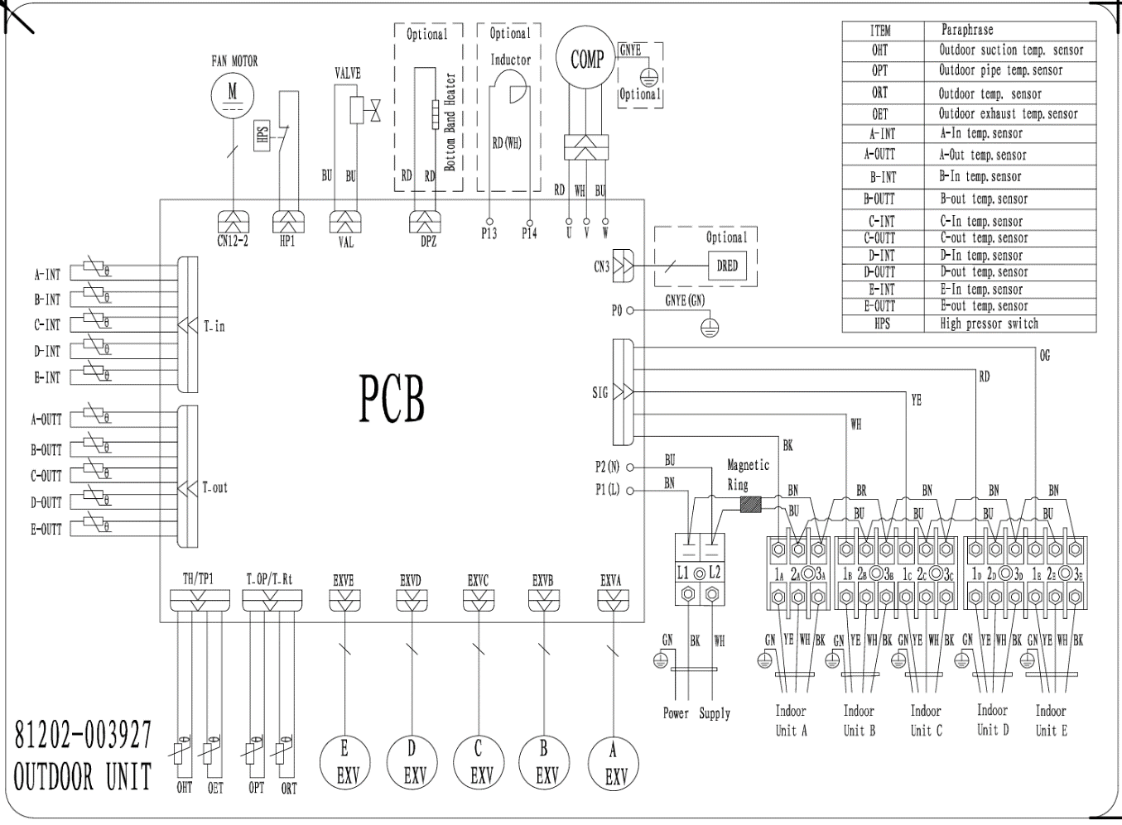

5.Precaution

5.1 SAFETY RULES AND RECOMMENDATIONS FOR THE INSTALLATION

Read this guide before installing and using the appliance.

During the installation of the indoor and outdoor units the access to the working area should be forbidden to children.

Unforeseeable accidents could happen.

Make sure that the base of the outdoor unit is firmly fixed.

Check that air cannot enter the refrigerant system and check for refrigerant leaks when moving the air conditioner.

Check that air cannot enter the refrigerant system and check for refrigerant leaks when moving the air conditioner.

The ratings of the fuse installed in the built in-control unit are T 5A / 250V.

The user must protect the indoor unit with a fuse of suitable capacity for the maximum input current or with another overload protection device.
- Ensure that the mains voltage corresponds to that stamped on the rating plate. Keep the switch or power plug clean. Insert the power plug correctly and firmly into the socket, thereby avoiding the risk of electric shock or fire due to insufficient contact.
- Check that the socket is suitable for the plug, otherwise have the socket changed.
- The appliance must be fitted with means for disconnection from the supply mains having a contact separation in all poles that provide full disconnection under over voltage category III conditions, and these means must be incorporated in the fixed wiring in accordance with the wiring rules.
- The air conditioner must be installed by professional or qualified persons. Do not install the appliance at a distance of less than 50 cm from inflammable substances (alcohol, etc.) Or from pressurized containers (e.g. spray cans).
- If the appliance is used in areas without the possibility of ventilation, precautions must be taken to prevent any leaks of refrigerant gas from remaining in the environment and creating a danger of fire.
- The packaging materials are recyclable and should be disposed of in the separate waste bins .Take the air conditioner at the end of its useful life to a special waste collection center for disposal.
- Only use the air conditioner as instructed in this booklet. These instructions are not intended to cover every possible condition and situation. As with any electrical household appliance, common sense and caution are therefore always recommended for installation, operation and maintenance.
- The appliance must be installed in accordance with applicable national regulations.
- Before accessing the terminals, all the power circuits must be disconnected from the power supply.
- The appliance shall be installed in accordance with national wiring regulations.
- This appliance can be used by children aged from 8 years and above and persons with reduced physical, sensory or mental capabilities or lack of experience and knowledge if they have been given supervision or instruction concerning use of the appliance in a safe way and understand the hazards involved. Children shall not play with the appliance. Cleaning and user maintenance shall not be made by children without supervision.

SAFETY RULES AND RECOMMENDATIONS FOR THE USER
- Do not try to install the conditioner alone; always contact specialized technical personnel. Cleaning and maintenance must be carried out by specialized technical personnel. In any case disconnect the appliance from the mains electricity supply before carrying out any cleaning or maintenance.
- Ensure that the mains voltage corresponds to that stamped on the rating plate. Keep the switch or power plug clean. Insert the power plug correctly and firmly into the socket, thereby avoiding the risk of electric shock or fire due to insufficient contact.
- Do not pull out the plug to switch off the appliance when it is in operation, since this could create a spark and cause a fire, etc.
- This appliance has been made for air conditioning domestic environments and must not be used for any other purpose, such as for drying clothes, cooling food, etc.
- The packaging materials are recyclable and should be disposed of in the separate waste bins. Take the air conditioner at the end of its useful life to a special waste collection center for disposal.
- Always use the appliance with the air filter mounted. The use of the conditioner without air filter could cause an excessive accumulation of dust or waste on the inner parts of the device with possible subsequent failures.
- The user is responsible for having the appliance installed by a qualified technician, who must check that it is earthed in accordance with current legislation and insert a thermomagnetic circuit breaker.
- The batteries in remote controller must be recycled or disposed of properly. Disposal of Scrap Batteries
--- Please discard the batteries as sorted municipal waste at the accessible collection point.
- Never remain directly exposed to the flow of cold air for a long time. The direct and prolonged exposition to cold air could be dangerous for your health .Particular care should be taken in the rooms where there are children, old or sick people.
- If the appliance gives off smoke or there is a smell of burning, immediately cut off the power supply and contact the Service Centre.
- The prolonged use of the device in such conditions could cause fire or electrocution.
- Have repairs carried out only by an authoritative Service Centre of the manufacturer. Incorrect repair could expose the user to the risk of electric shock, etc.
- Unhook the automatic switch if you foresee not to use the device for a long time. The airflow direction must be properly adjusted.
- The flaps must be directed downwards in the heating mode and upwards in the cooling mode.
- Only use the air conditioner as instructed in this booklet. These instructions are not in ended to cover every possible condition and situation. As with any electrical household appliance, common sense and caution are therefore always recommended for installation, operation and maintenance.
- Ensure that the appliance is disconnected from the power supply when it will remain inoperative for a long period and before carrying out any cleaning or maintenance.
- Selecting the most suitable temperature can prevent damage to the appliance.

  - SAFETY RULES AND PROHIBITIONS
- Do not bend, tug or compress the power cord since this could damage it. Electrical shocks or fire are probably due to a damaged power cord. Specialized technical personnel only must replace a damaged power cord.
- Do not use extensions or gang modules.
- Do not touch the appliance when barefoot or parts of the body are wet or damp.
- Do not obstruct the air inlet or outlet of the indoor or the outdoor unit. The obstruction of these openings causes a reduction in the operative efficiency of the conditioner with possible consequent failures or damages.
- In no way alter the characteristics of the appliance.
- Do not install the appliance in environments where the air could contain gas, oil or sulphur or near sources of heat.
- This appliance is not intended for use by persons (including children) with reduced physical, sensory or mental capabilities, or lack of experience and knowledge, unless they have been given supervision or instruction concerning use of the appliance by a person responsible for their safety.
- Do not climb onto or place any heavy or hot objects on top of the appliance.
- Do not leave windows or doors open for long when the air conditioner is operating.
- Do not direct the airflow onto plants or animals.
- A long direct exposition to the flow of cold air of the conditioner could have negative effects on plants and animals.
- Do not put the conditioner in contact with water. The electrical insulation could be damaged and thus causing electrocution.
- Do not climb onto or place any objects on the outdoor unit
- Never insert a stick or similar object into the appliance. It could cause injury.
- Children should be supervised to ensure that they do not play with the appliance. If the supply cord is damaged, it must be replaced by the manufacturer, its service agent or similarly qualified persons in order to avoid a hazard.

6.Names of parts
Wall split type

Indoor unit
No. | Name
1 | Front panel
2 | Air filter
3 | Special filter(option)
4 | Display PCB
5 | Vertical vane
6 | Horizontal vane
7 | Remote controller
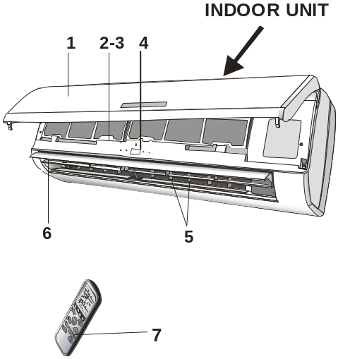

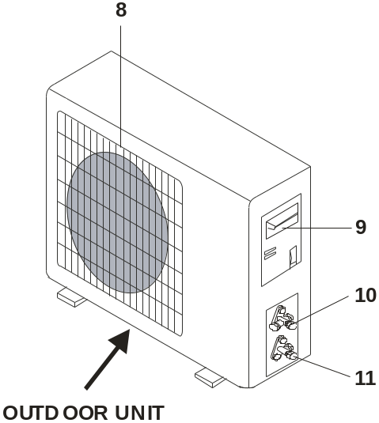

Outdoor unit
No. | Name
8 | Air outlet grille
9 | Electronic box cover
10 | 2-way valve
11 | 3-way valve

Outdoor unit
No. | Name
8 | Electronic box cover
9 | 2-way valve
10 | 3-way vale

Display
No. | Name
1 | Power
2 | Sleep
3 | Temperature display
4 | Timer
5 | Run
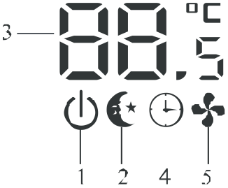
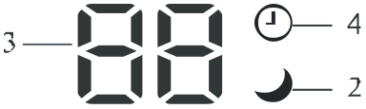

Outdoor unit
No. | Name
8 | Electronic box cover
9 | 2-way valve
10 | 3-way vale

Cassette type

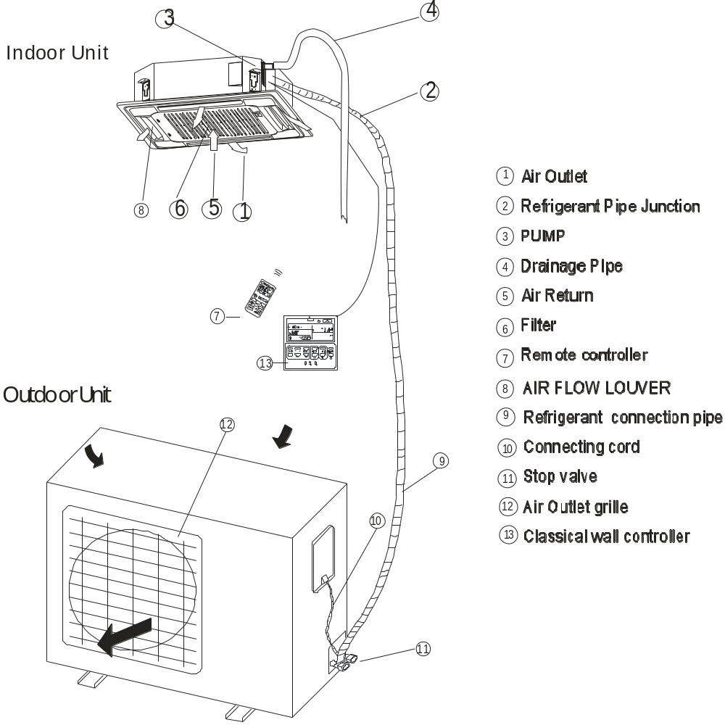
Display
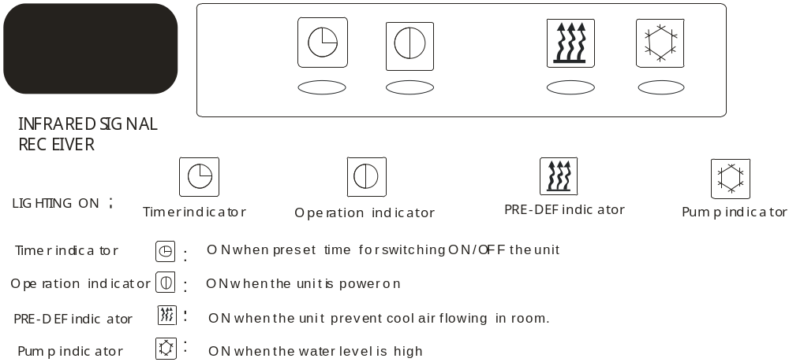

Duct type

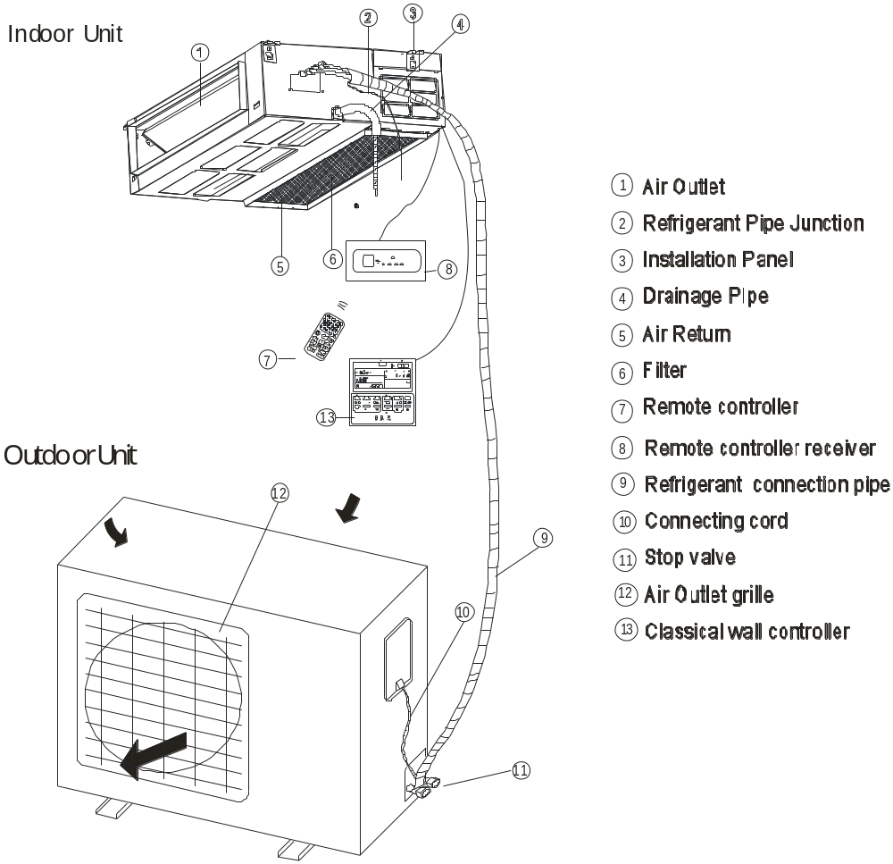

DISPLAY
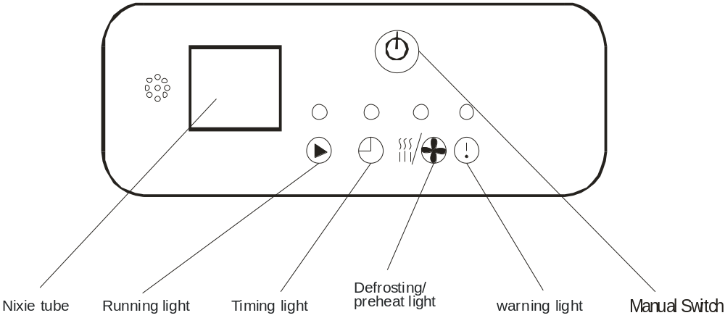

7.Installation manual
7.1 Installation Details
Connecting pipe length

Model | Pipe size(Inch)
Model | Liquid | Gas
7K | 1/4 | 3/8
9K | 1/4 | 3/8
12K | 1/4 | 3/8
18K | 1/4 | 3/8
24K | 1/4 | 1/2

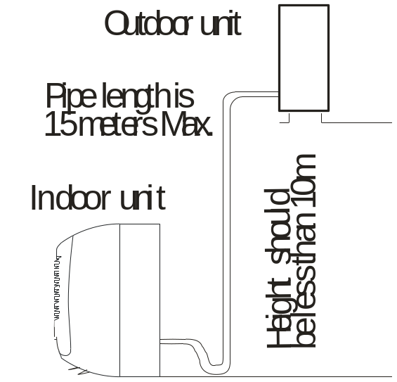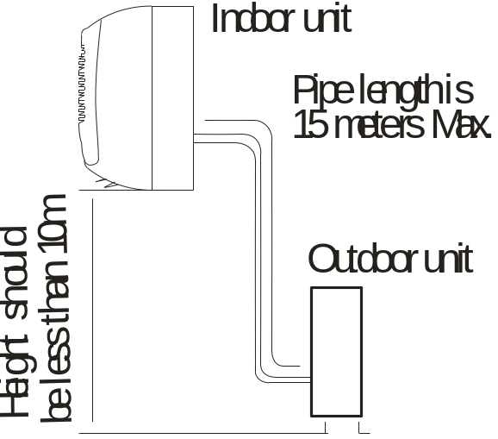

Mode | Standard length: m | Refrigerant piping Max. length: m  A | Additional refrigerant  Calculation: ×g=20g/m(A-5m)
9K | 5.0 | 15 | 15g/m
12K | 5.0 | 15 | 15g/m
18K | 5.0 | 15 | 20g/m
24K | 5.0 | 15 | 20g/m

Connecting cables
The power cord should be selected according to the following specifications sheet.
Appliance Amps | Wire Size
5 | AWG21/0.75 mm2
10 | AWG18/1.0 mm2
13 | AWG15 /1. 5 mm2
18 | AWG14/1.6 mm2
25 | AWG12/2.0 mm2
30 | AWG10/2.5 mm2

  - Installation for the first time
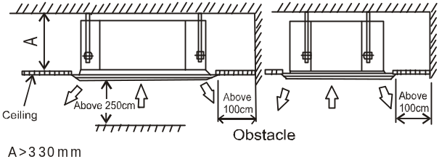Indoor unit
Wall type:

      - Install the indoor unit level on a strong wall that is not subject to vibrations
- The inlet and outlet ports should not be obstructed: the air should be able to blow all over the room.
- Do not install the unit near a source of heat, steam, or flammable gas.
- Install the unit near an electric socket or private circuit.
- Do not install the unit where it will be exposed to direct sunlight.
- Install the unit where connection between indoor and outdoor unit is as easy as possible.
- Install the unit where it is easy to drain the condensed water.
- Check the machine operation regularly and leave the necessary spaces as shown in the picture.
- Install the indoor unit where the filter can be easily accessible.
- Install the indoor unit in the room to be air conditioning, avoiding to installation in corridors or communal areas.
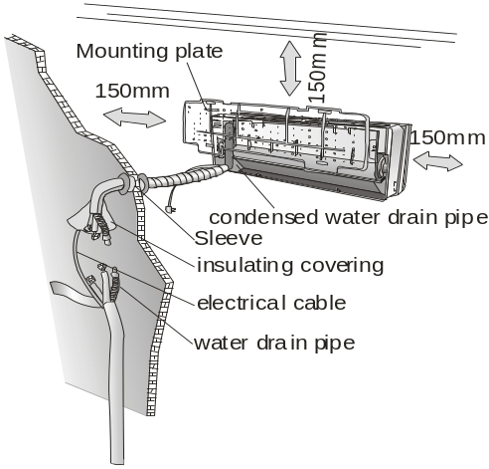

- Install the indoor unit at a height of at least 2.5m
from the ground.
Cassette type:
- Be sure to lead the refrigerant pipes, drain pipes and connection wires out to its connection location before hanging the unit if the opening on the ceiling has been decided.
- Confirm sizes of the indoor unit and ceiling opening with the attached installation paper pattern. (Please
fix the paper pattern below the body with M5X16
screws (4).

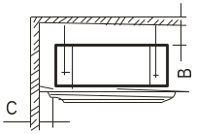

Wall material | Flammable  material | Fire-proof or nonflammable  materials | Fire-proof  structure
B | Above 5cm | Above 5cm | Above 5cm
C | Above 100cm | Above 100cm | -
Duct
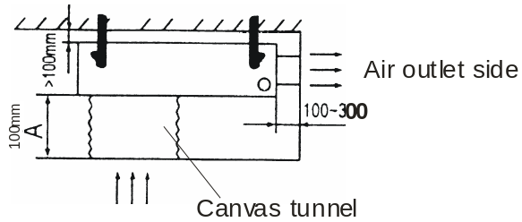

OUTDOOR UNIT
- Do not install the outdoor unit near sources of heat, steam or flammable gas.
- Do not install the unit in too windy or dusty places.
- Do not install the unit where people often pass. Select a place where the air discharge and operating sound level will not disturb the neighbours.
- Avoid installing the unit where it will be exposed to direct sunlight (other wise use a protection, if necessary, that should not interfere with the air flow).
- Leave the spaces as shown in the picture for
- The air to circulate freely.
- Install the outdoor unit in a safe and solid place.
- If the outdoor unit is subject to vibration, place rubber gaskets onto the feet of the unit.
Minimum space to be left (mm) showing in the picture.

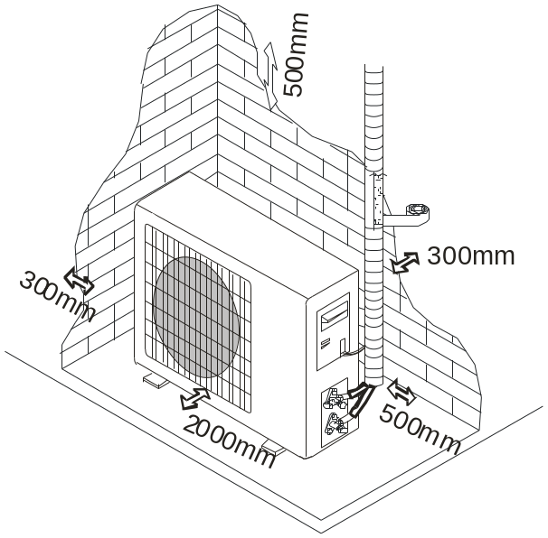

To install, proceed as follows:
    - Installation of the mounting plate.
Wall split type:
      - By using a level, put the mounting plate in a perfect square position vertically and horizontally.
      - Drill 32mm deep holes in the wall to fix the plate.
      - Insert the plastic anchors into the hole.
      - Fix the mounting plate by using the provided tapping screws.
      - Check that the mounting plate is correctly fixed.
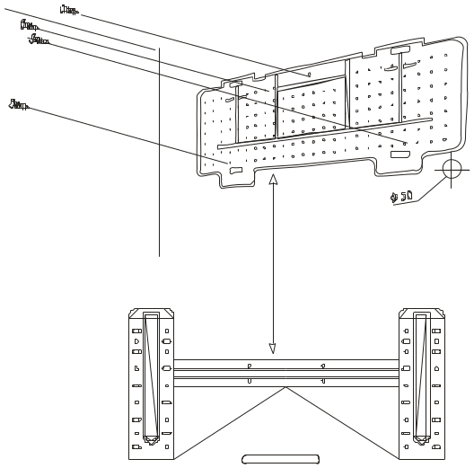

Note: The shape of the mounting plate may be different from the one above, but installation method is similar.
Cassette and Duct type:
Wooden construction
Put the square timber over the roof beam, then install the hanging screw bolts.
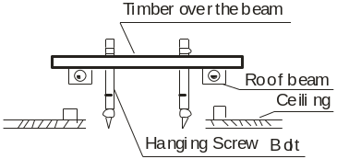
For finished concrete bricks
Install the hanging hook with expansible bolt into the concrete deep to 45~50mm to prevent loose.
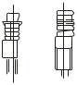
New Concrete Bricks
Inlaying or embedding the screw bolts.
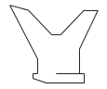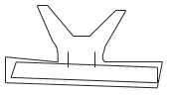
(Blade shape (Slide insertion)
insertion)
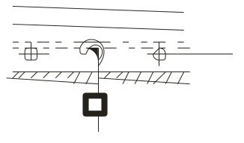
Embedding screw bolt
Steel bar
(Pipe hanging and embedding screw bolt)
Steel roof beam structure
Install the supporting angle steel.
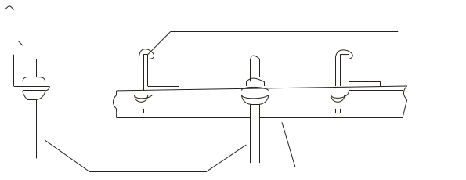
Hanging bolts
Hanging screw bolt
Supporting
angle steel
Overhanging the indoor unit
Adjust the gasket (down side) to 90mm over the ceiling.
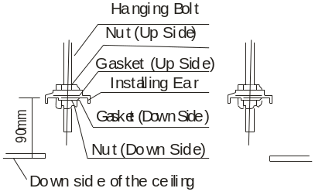

Install the hanging bolt into T groove of the hanging tool. Overhang the indoor unit and ensure it is level using a level indicator.

cassette
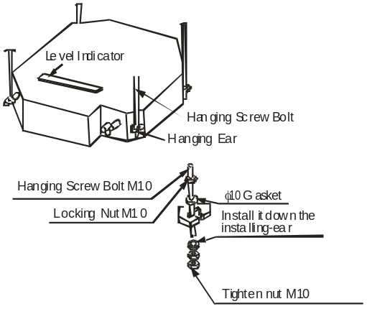

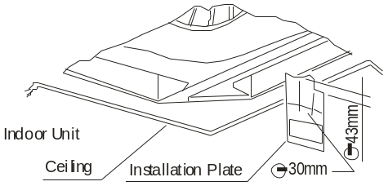

Duct
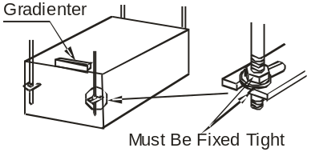

How to mount outlet pipe.
- Generally, we have two types of outlet pipe available, i.e. rectangular or round ones.
- Rectangular air conduit can be directly connected to air outlet of indoor unit by rivets. For outlet dimensions, see outline drawing of the unit.
- Round air conduit should be connected to a piece of transitional air conduit before it is connected to air outlet of indoor unit, the other end of it can be separately connected to air conduit window or connected to air conduit window after air flow diversion, and the total length should not be over 6m. As shown in figure below, air speeds at all air outlets should be set to basically consistent so as to meet the room air-conditioning requirements.
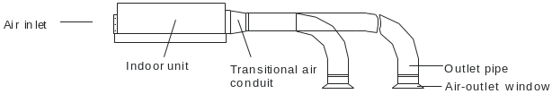

Installation method for return air pipe
- In case sidewise air intake is adopted, return air pipe should be fabricated and rivet-connected to return air orifice, and the other end of it should be connected to return air window.
- In case of underside air intake, purchase or fabricate a section of pleated canvas air conduit serving as transition joint for return air orifice and return air window. in this way, it can be freely adjusted according to height of indoor ceiling board; in addition, during operation of the unit , canvas air conduit may avoid vibration of ceiling board, as shown in figure below.
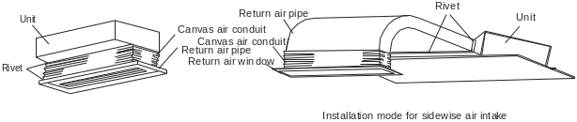

    - Drilling a hole in the wall for the piping
- Decide where to drill the hole in the wall for the piping (if necessary) according to the position of the mounting plate
- Install a flexible flange through the hole in the wall to keep the latter intact and clean.
The hole must slope downwards towards the exterior.
Note: Keep the drain pipe down towards the direction of the wall hole, otherwise leakage may occur.
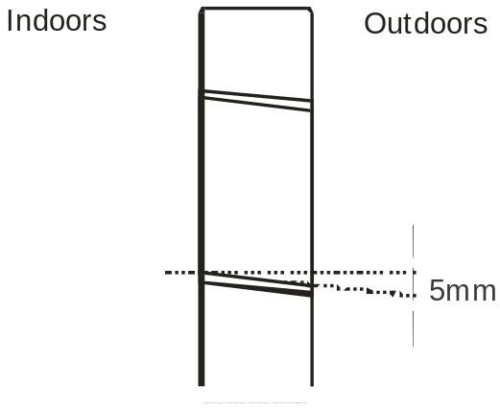

    - Electrical connections---Indoor unit
1).Lift the front panel.
2).Take off the cover as indicated in the picture (by removing a screw or by breaking the hooks).
3).For the electrical connections, see the circuit diagram on the right part of the unit under the front panel.
4).Connect the cable wires to the screw terminals by following the numbering, Use wire size suitable to the electric power input (see name plate on the unit) and according to all current national safety code requirements.
5).The cable connecting the outdoor and indoor units must be suitable for outdoor use.
6).The plug must be accessible also after the appliance has been installed so that it can be pulled out if necessary.
7).An efficient earth connection must be ensured.
8).If the power cable is damaged, it must be
replaced by an authorized Service Centre.
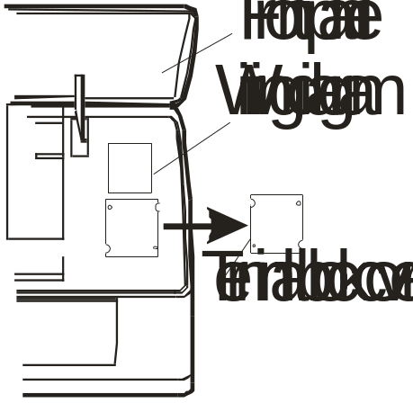

    - Refrigerant piping connection
The piping can be run in the 3 directions indicated by numbers in the picture. When the piping is run in direction 1 or 3, cut a notch along the groove on the side of the indoor unit with a cutter.
Run the piping in the direction of the wall hole and bind the copper pipes, the drain pipe and the power cables together with the tape with the drain pipe at the bottom, so that water can flow freely.
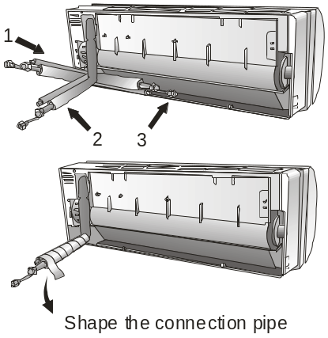

    - Connecting the pipes.
- Do not remove the cap from the pipe until connecting it, to avoid dampness or dirt from entering.
- If the pipe is bent or pulled too often, it will become stiff. Do not bend the pipe more than three times at one point.
- When extending the rolled pipe, straighten the pipe by unwinding it gently as shown in the picture.
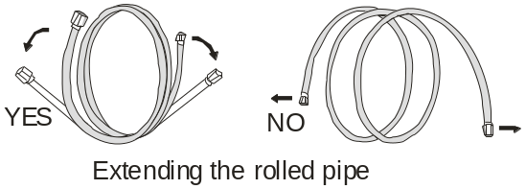

    - Connections to the indoor unit
1).Remove the indoor unit pipe cap (check that there is no debris inside).
2).Insert the fare nut and create a flange at the extreme end of the connection pipe.
3).Tighten the connections by using two wrenches working in opposite directions.
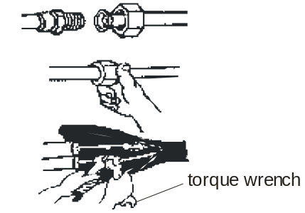

    - Indoor unit condensed water drainage
The indoor unit condensed water drainage is fundamental for the success of the installation.
1).Place the drain hose below the piping, taking
care not to create siphons.
2).The drain hose must slant downwards to aid drainage.
3).Do not bend the drain hose or leave it protruding or twisted and do not put the end of it in water. If an extension is connected to the drain hose, ensure that it is lagged when it passes into the indoor unit.
4).If the piping is installed to the right, the pipes, power cable and drain hose must be lagged and secured onto the rear of the unit with a pipe connection.
- Insert the pipe connection into the relative slot.
- Press to join the pipe connection to the base.
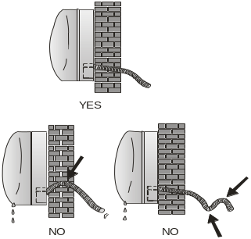

For Cassette and Duct type
- The drain pipe of indoor unit must have the heat insulation , or it will condense dew, as well as the connections of the indoor unit.
- The declivity of the drain pipe downwards should not be over 1/100, and no winding and bending.
- The total length of the drain pipe when pulled out traversely shall not exceed 20m , when the pipe is over long, a prop stand must be installed every 1.5 to 2m to prevent winding.
- Refer to the following figures about the installation of the pipes.
- Do not impose any pressure on the connection part of the drainage pipe.
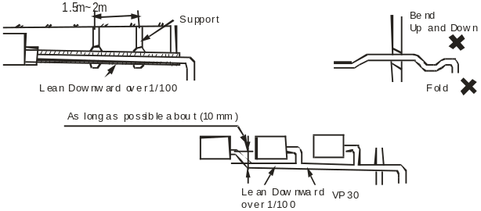

    - Electronic connections of outdoor unit
- Take the cover away.
- Connect the cable wires to the terminal board using the same numbering as in the indoor unit.
- For the electrical connections, see the wiring diagram on the back of the cover
- Fasten the cables with a cable-clamp.
- An efficient earth connection must be ensured.
- Replace the covers.
Wiring diagram on the back of the cover

Screw
Remove the upper cover

Outdoor unit
    - Connecting the pipe of outdoor unit
Screw the flare nuts to the outdoor unit coupling with the same tightening procedures described for the indoor unit.
Note: If the tightening torque is not sufficient, there will probably be some leakage. With excessive tightening torque there will also be some leakage, as the flange could be damaged.
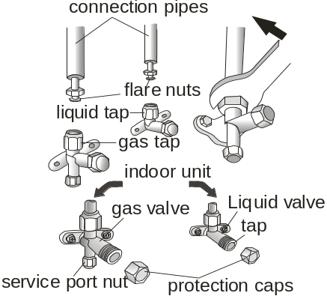

    - Bleeding
Air and humidity left inside the refrigerant circuit can cause compressor malfunction. After having connected the indoor and outdoor units, bleed the air and humidity from the refrigerant circuit by using a vacuum pump.
The air and humidity left inside the refrigerant circulation can cause compressor malfunction. After having connected the indoor and outdoor units, bleed the air and humidity from the refrigerant circulation using a vacuum pump.
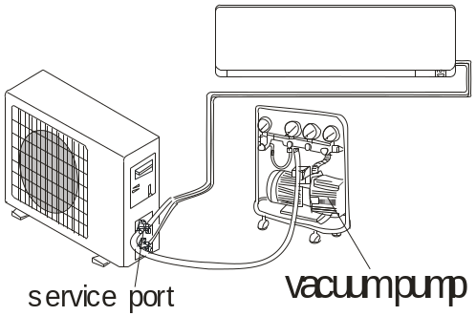

Notice
According to installation conditions, overlarge wrenched Torch will destroy the nut. (Unit. N.cm)
Pipe | Tightening torque(N.M)
1/4’’ | 15-20
3/8’’ | 31-35
1/2’’ | 45-50
5/8’’ | 60-65
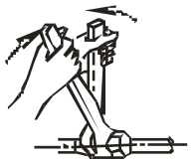

8.Trouble shooting
8.1 E0 Error- IDU & ODU communication failure

Start

Display E0

No
Yes
IDU wiring
connection correct ?
No
E0 disappear?
Check and re-connect

No
Yes

Yes
Replace/ re-connect
Check communication, earth wiring and the connection, in good condition?
No
E0 disappear?

No
Yes
Yes
No n
ODU wiring
Connection correct?
E0 disappear?

Check and re-connect

No
Yes

Check voltage from IDU terminal btw L,N. is there
220V?
No
No
Check the power supply connection
Main power supply from IDU?

Yes
Yes
Replace or reconnect
Check voltage from IDU terminal btw L,N. is there
220V?

Replace IDU PCB
No
No
Replace ODU PCB

Is the ODU PCB LED ON?
Yes
Yes
E0 disappear?

Yes
No
Yes
Flash or not?
Yes
No
Is the ODU PCB
LED ON?
Replace ODU PCB

Yes
No
Yes
No
Yes
E0 disappear?
First replace IDU PCB

E0 disappear?
ON constantly

Flash

First replace IDU PCB

Yes
E0 disappear?

No
Yes
E0 disappear?

No
Replace ODU PCB

Replace ODU PCB

End
8.2 E1, E2 ---IDU Room temperature sensor and/or coil temperature sensor failure.

Start

Display E1or E2

No
Is the sensor well connected to PCB
Re-connect

Yes
E1/E2 disappear?
Yes
No

Multi-meter check the sensor, is it open or short circuit?
Yes
Replace the sensor

Yes
The malfunction eliminated?
No
No

Replace IDU PCB

End

8.3 E4 --- System abnormal (Gas not enough)

Start

Display E4

Check the pressure

AC pressure correct?
(cooling:0.8-1.3Mpa,/
heating 2.0-3.6Mpa)
Yes
No
Check the sensor short or open?

Yes
No

Replace the sensor

No
Check the valves open or not

Replace the main PCB

Yes
Open the valves

Lower than 0.8 Mpa in cooling, 2.0 Mpa in heating, is not enough

Add gas

No
E4 display?

Yes

System block

Maintain the system

End

8.4 E6----IDU ventilation failure (PG and DC fan motor only)

Start

Display E6

Turn the fan blades by hand while power-off condition

Adjust the motor and blade assembly so that rotor can run smoothly.
No
Can the fan blades run smoothly?

Yes
No
Yes
E6 disappear?

Fan motor well connected to PCB
Check and reconnect

No
Yes
Yes
E6 disappear?

Multi-meter check resistance of fan motor, is there open or short circuit of winding?
Yes
Replace fan motor

Yes
E6 disappear?
No

No

Replace IDU PCB

End

8.5 E3, E7 or E8----ODU Coil temperature sensor, Ambient temperature sensor or Discharge temperature sensor failure.

When any of the sensor resistance open or short circuit , unit will display failure code as E3/E7 or E8, IDU and ODU turns off. When the sensor resistance recovery, unit revert to be standby, customer can switch on the unit directly.

Start

Display E3, E7 or E8

No
Is the sensor well connected to ODU PCB ?
Re connect

Problem solved ?
Yes
Yes
No

Multi-meter check the sensor resistance.
Open or short circuit?
Replace sensor
Yes

No
Problem solved?
Yes
No

Replace ODU PCB

End

8.6 E9---ODU IPM /Compressor drive fault

If unit have 6 times stopping works for IPM protection (P0) continuously, it will display E9 error, and unit can’t be recovered to operation, except press ON/OFF button.
Display E9

Cut the power and supply again, restart unit. It works normal?
Yes

No

Replace outdoor PCB
E9 disappear?
Display E9
Display E9 or P0?

Display P0
Replace compressor
Yes
Restart unit. It works normal?

No

P0 disappear?
No
Yes
Re-connect
Wiring connection U/V/W correct?
No
Yes
Yes
Replace ODU fan motor
ODU fan motor no works or too slowly?
Yes
Can compressor start up?

Yes
No
Works normal?
No
No

AC pressure correct?
(cooling:0.8-1.3Mpa,/
heating 2.0-3.6Mpa)
Test voltage btw U/V/W-G , (normally from DC 20~200V.)
Yes
No

No
Replace ODU PCB
Yes
Yes
Is the condenser and/or evaporator too dirty?
Clean it
Yes
Turn unit on to check whether the malfunction is eliminated.
Yes
No
Unit works normal?
No
No
No
Capillary blocked?
Replace compressor
Yes
Replace capillary

No
P0 disappear?

Yes
End

8.7 EF---ODU DC fan motor failure

Shut off

No
Re install the DC motor
Check the fan blade by hand, can it rotate freely

Yes
Works normal?
Yes

No

Fan motor well connect to PCB
No
Re-connect

Works normal?
Yes
Yes

No

1. For built-in control (5pins) motor: check the V_{m}=310V? V_{cc}=15V?
2. For external control (3pins) motor: test voltage btw U/V/W , normally from DC 20~200V.
Check the fan motor, can it operate or not.
Yes

Yes
Works normal?
No

No

Replace fan motor

No
Replace ODU PCB
Works normal?

Yes

End

8.8 EU---ODU voltage test sensor failure

After power relay works, when tested voltage effective value less than 50V for 3s continuously, unit will display EU.

Start

Display EU

No
Test voltage btw ODU terminal L/N, more than 50V~?
Check while voltage become normal

Yes

Unit works?
Yes

No

Replace ODU PCB

End

8.9 Ey, En, EH---- Outdoor liquid pipe temperature sensor, Outdoor gas pipe temperature sensor or suction pipe temperature sensor failure.

When any of the sensor resistance open or short circuit , unit will display failure code as Ey, En or EH, IDU and ODU turns off. When the sensor resistance recovery, unit revert to be standby, customer can switch on the unit directly.

Start

Display Ey or En

No
Is the sensor well connected to ODU PCB ?
Reconnect

Problem solved ?
Yes
Yes
No

Multi-meter check the sensor resistance.
Open or short circuit?
Replace sensor
Yes

No
Problem solved?
Yes
No

Replace ODU PCB

End

8.10 EC--- Outdoor communication failure
EA--- Current sensor fault
EE--- Outdoor EEPROM fault
Display P0

Cut off the power and supply again

No
Replace the outdoor PCB
Whether the unit can operate at normal?

Yes

End

8.11 d3--- Water full protection
Display d3

Replace the indoor PCB
No
Check whether water full?

Yes
Yes
Yes
d3 disappear?
Check the unit whether installation balance?

No
No
Adjust to balance

No
Replace the indoor PCB
Check whether water pump fail?

Yes
Replace the water pump

End

8.12 P0---IPM protection

When overheat or overcurrent for IPM, AC unit will display P0 protection.

Display P0

Yes
Restart unit. It works normal?

No
No
Wiring connection U/V/W correct?
Re-connect
Yes
Yes
P0 disappear?

No

ODU fan motor no works or too slowly?
Yes
Yes
Replace ODU fan motor
Can compressor start up?

Yes
No
No
No
Works normal?

AC pressure correct?
(cooling:0.8-1.3Mpa,/
heating 2.0-3.6Mpa)
Test voltage btw U/V/W-G , (normally from DC 20~200V.)
No
Yes

Yes
Replace ODU PCB
No

Yes
Clean it
Is the condenser and/or evaporator too dirty?
Yes
Turn unit on to check whether the malfunction is eliminated.

Yes
No
Unit works normal?
No
No

No
Capillary blocked?
Replace compressor
Yes

Replace capillary

No
P0 disappear?

Yes
End

8.13 P1--- Lower voltage protection

1. Test voltage between L &N, When the power supply V＜AC155V, AC will display P1 protection, unit will recover back to previous status while V＞AC155V.
2. Test voltage on the big size electrolytic capacitor of ODU PCB, When DC busbar voltage V＞DC420V or V＜DC150V, unit will recover back to previous status while DC190V＜V＜DC410V

Display P1

Is the power supply voltage btw145-260V?
Wait until the AC voltage recovery
No

Yes
Is the power supply voltage btw145-260V?
Yes

No

Wait until the busbar voltage recovery

No
Is the busbar voltage btw150-420V?

Yes
Yes
Unit works normal?

No

Replace ODU PCB

End

8.14 P2---Over Current protection

When the AC unit running current more than I_{max}, it will stop and display P2 protection.
Note: for different AC model, I_{max} has difference valve.

Display P2

IDU fan motor works?
Replace fan motor
No

Yes
Yes
P2 disappear?

No

Clean IDU filter or condenser
IDU filter or ODU condenser too dirty?
Yes

No

No
Re-start the unit, P2 disappear?

Replace ODU PCB

Yes

End

8.15 P4 ---ODU Discharge temperature overheating protection
Display P4

Yes
ODU temperature higher than 60℃?

Normal protection

No

Yes
Enough space for ventilation?
No
ODU location acceptable?

Adjust ODU installation
Unit operate?

No

Yes
No
Yes

Yes
P4 disappear?
Clean IDU filter or ODU condenser.
Condenser too dirty? or filter blocked?
Yes

No
No

IDU/ODU fan motor running slowly or stopped?
Yes
Yes
Adjust
Fan blade blocked?

No
No
Problem solved?
Yes
Replace fan motor or PCB

No

Replace capillary
Yes
Problem solved?
Capillary blocked?
Yes

No
No

Yes
Yes
Is the unit gas
pressure normal? (cooling0.8-1.3Mpa,
heating2.0-3.6Mpa)
Problem solved?

Charge gas

No
No
Replace ODU PCB

End

8.16 P5---Sub-cooling protection on Cooling/Dry mode

On Cooling or Dry mode, when IDU evaporator coil temperature IPT＜1℃ continuously for 3 min after compressor start up for 6 min, CPU will switch off outdoor unit and show P5 protection code.

Display P5

Switch on unit after minutes

Yes
Clean filter
Yes
IDU filter dirty?
Display P5

No
Yes
No
No
P5 disappear?
Normal protection

Yes
IDU air inlet blocked?
P5 disappear?
Clean
Yes

No
No

Yes
Check and repair fan blade
P5 disappear?

No
Can fan blade rotate freely?
Note: Cooling mode under low environment temperature easily have P5 protection
No
Yes

Yes
Fan motor works too slow or stopped
Yes
Fan motor defect?
Replace motor

No
No

Sensor IPT abnormal?
Yes
Replace sensor

No

Replace IDU PCB

End

8.17 P6---Overheating protection on Cooling mode

On Cooling or Dry mode, when ODU condenser coil temperature OPT≥62℃ , MCU will switch off outdoor unit and show P6 protection code.

Display P6

Yes
No
ODU fan motor works normal?
Fan motor broken?
Replace fan motor

Yes
No
Yes
No
P6 disappear?

Yes
Sensor loosing from connector?
P6 disappear?

Re-connect sensor

No
Yes

No
The sensor open or short circuit?

Yes

Replace OPT sensor

Yes
P6 disappear?

No

Replace ODU PCB

End

8.18 P7---Overheating protection on Heating mode
On heating mode, when IDU evaporator coil temperature IPT≥62℃, ODU PCB will switch off outdoor unit and show P7 failure code.

Display P7

Fan motor broken?
Yes
No
IDU fan motor works normal?
Replace fan motor

Yes
No
Yes
No
P7 disappear?

Sensor loosing from connector?
Yes
P7 disappear?

Re-connect sensor

No
Yes

No
The sensor open or short circuit?

Yes

Replace IPT sensor

Yes
P7 disappear?

No

Replace IDU PCB

End

8.19 P8---Outdoor Over-temperature/Under-temperature protection

When environment temperature as below condition, the compressor will stop working, after 200s delay, the IDU will show P8 failure code.
(1). On Cooling or Dry mode: ODU ambient temperature: OAT＜-20℃ or OAT＞63℃;
(2). On Heating mode:
a. OAT≥40℃
b. 30℃＜OAT≤40℃ and RT＞35℃
Display P8

No enough space for ODU ventilation?
Ambient temperature under spec. range?
Change ODU location
Yes
No

No
Yes
No
P8 disappear?

Yes
No
The sensor open or short circuit?

Yes

Replace OAT sensor

No
P8 disappear?

Yes

Replace ODU PCB

End

8.20 P9---The compressor driving protection (the compressor load abnormal)

When compressor start up or in the process of operation, if:
(1). MCU can’t test the feedback signal from compressor, or
(2). Tested a abnormal signal from compressor, or
(3). The compressor startup abnormal.
The outdoor unit will shut off, and show P9 protection.
(The unit will re-startup 6 times continuously, if it still can’t work normal, then show P9 code)

Display P9

Re-correct wires
Check the compressor wires U/V/W sequency & connection, CORRECT?
No

Yes
Yes
Still P9?

No
Yes
Starts up the unit less than 3 minutes while it stopped?
Normal protection as the High pressure and Low pressure not balance.

No

Re-start after 3minutes
The compressor stops at once while it starts up

Yes
Replace ODU PCB
Still P9?
No

End

8.21 PA---Mode conflict.
If one run in cooling and another run in heating, the unit will display PA code.

Start

Display PA

Check whether one operate in cooling and the other operate in heating model?
No

Yes
Change the other unit to the same model

No
Change the outdoor PCB
PA disappear?

Yes
End

  - CL---Duty caution
Air filter duty, the unit operation Cumulative time 500 hours, the controller will confirmation the filter dirty and display CL.

Display CL

No
Check whether the air filter duty?

Yes

Clean the air filter

Cut off the power and supply again

End

9.THERMISTOR TEMPERATURE CHARACTERISTICS
1. Indoor unit and outdoor exchange temperature and outside air temperature sensor temperature characteristics
TEMP.  (℃) | R min  (k Ohm) | R(t)  (k Ohm) | R max  (k Ohm) | TEMP.  (℃) | R min  (k Ohm) | R(t)  (k Ohm) | R max  (k Ohm) | TEMP.  (℃) | R min  (k Ohm) | R(t)  (k Ohm) | R max  (k Ohm)
-30 | 60.343 | 64.104 | 68.080 | 21 | 5.716 | 5.846 | 5.977 | 72 | 0.974 | 1.010 | 1.047
-29 | 57.157 | 60.666 | 64.375 | 22 | 5.498 | 5.620 | 5.742 | 73 | 0.944 | 0.980 | 1.016
-28 | 54.139 | 57.413 | 60.870 | 23 | 5.290 | 5.404 | 5.518 | 74 | 0.917 | 0.952 | 0.988
-27 | 51.301 | 54.355 | 57.579 | 24 | 5.091 | 5.198 | 5.305 | 75 | 0.890 | 0.924 | 0.959
-26 | 48.630 | 51.480 | 54.487 | 25 | 4.900 | 5.000 | 5.100 | 76 | 0.864 | 0.897 | 0.931
-25 | 46.115 | 48.776 | 51.582 | 26 | 4.713 | 4.811 | 4.909 | 77 | 0.839 | 0.871 | 0.904
-24 | 43.748 | 46.232 | 48.850 | 27 | 4.533 | 4.630 | 4.727 | 78 | 0.814 | 0.846 | 0.879
-23 | 41.517 | 43.836 | 46.279 | 28 | 4.362 | 4.457 | 4.552 | 79 | 0.791 | 0.822 | 0.854
-22 | 39.415 | 41.581 | 43.861 | 29 | 4.199 | 4.292 | 4.386 | 80 | 0.769 | 0.799 | 0.830
-21 | 37.432 | 39.456 | 41.585 | 30 | 4.042 | 4.133 | 4.225 | 81 | 0.746 | 0.776 | 0.807
-20 | 35.581 | 37.473 | 39.462 | 31 | 3.892 | 3.982 | 4.072 | 82 | 0.725 | 0.754 | 0.784
-19 | 33.798 | 35.565 | 37.421 | 32 | 3.748 | 3.836 | 3.925 | 83 | 0.705 | 0.733 | 0.762
-18 | 32.134 | 33.785 | 35.519 | 33 | 3.611 | 3.697 | 3.784 | 84 | 0.685 | 0.713 | 0.742
-17 | 30.561 | 32.105 | 33.725 | 34 | 3.479 | 3.564 | 3.649 | 85 | 0.666 | 0.693 | 0.721
-16 | 29.077 | 30.520 | 32.033 | 35 | 3.353 | 3.436 | 3.520 | 86 | 0.647 | 0.674 | 0.701
-15 | 27.673 | 29.023 | 30.437 | 36 | 3.232 | 3.313 | 3.395 | 87 | 0.629 | 0.655 | 0.682
-14 | 26.347 | 27.609 | 28.931 | 37 | 3.116 | 3.195 | 3.275 | 88 | 0.613 | 0.638 | 0.664
-13 | 25.092 | 26.273 | 27.508 | 38 | 3.004 | 3.082 | 3.161 | 89 | 0.595 | 0.620 | 0.646
-12 | 23.905 | 25.010 | 26.165 | 39 | 2.898 | 2.974 | 3.051 | 90 | 0.580 | 0.604 | 0.629
-11 | 22.782 | 23.816 | 24.896 | 40 | 2.795 | 2.870 | 2.946 | 91 | 0.563 | 0.587 | 0.611
-10 | 21.720 | 22.687 | 23.697 | 41 | 2.697 | 2.770 | 2.844 | 92 | 0.549 | 0.572 | 0.596
-9 | 20.713 | 21.618 | 22.562 | 42 | 2.604 | 2.675 | 2.748 | 93 | 0.534 | 0.557 | 0.580
-8 | 19.759 | 20.607 | 21.490 | 43 | 2.513 | 2.583 | 2.654 | 94 | 0.520 | 0.542 | 0.565
-7 | 18.855 | 19.649 | 20.475 | 44 | 2.426 | 2.494 | 2.564 | 95 | 0.506 | 0.528 | 0.550
-6 | 17.999 | 18.742 | 19.515 | 45 | 2.343 | 2.410 | 2.478 | 96 | 0.493 | 0.514 | 0.536
-5 | 17.187 | 17.883 | 18.606 | 46 | 2.263 | 2.328 | 2.395 | 97 | 0.480 | 0.501 | 0.522
-4 | 16.416 | 17.068 | 17.745 | 47 | 2.186 | 2.250 | 2.315 | 98 | 0.468 | 0.488 | 0.509
-3 | 15.685 | 16.296 | 16.930 | 48 | 2.111 | 2.174 | 2.238 | 99 | 0.456 | 0.476 | 0.497
-2 | 14.991 | 15.563 | 16.156 | 49 | 2.041 | 2.102 | 2.164 | 100 | 0.444 | 0.464 | 0.484
-1 | 14.332 | 14.868 | 15.423 | 50 | 1.972 | 2.032 | 2.093 | 101 | 0.433 | 0.452 | 0.472
0 | 13.766 | 14.270 | 14.792 | 51 | 1.906 | 1.965 | 2.025 | 102 | 0.422 | 0.441 | 0.460
1 | 13.111 | 13.582 | 14.069 | 52 | 1.844 | 1.901 | 1.959 | 103 | 0.412 | 0.430 | 0.449
2 | 12.546 | 12.987 | 13.443 | 53 | 1.783 | 1.839 | 1.896 | 104 | 0.401 | 0.419 | 0.437
3 | 12.008 | 12.422 | 12.849 | 54 | 1.724 | 1.779 | 1.835 | 105 | 0.391 | 0.409 | 0.427
4 | 11.497 | 11.885 | 12.284 | 55 | 1.668 | 1.721 | 1.776 | 106 | 0.381 | 0.399 | 0.416
5 | 11.012 | 11.375 | 11.749 | 56 | 1.614 | 1.666 | 1.719 | 107 | 0.372 | 0.388 | 0.406
6 | 10.548 | 10.889 | 11.239 | 57 | 1.562 | 1.613 | 1.665 | 108 | 0.362 | 0.379 | 0.395
7 | 10.109 | 10.428 | 10.756 | 58 | 1.512 | 1.562 | 1.613 | 109 | 0.353 | 0.369 | 0.386
8 | 9.689 | 9.988 | 10.295 | 59 | 1.463 | 1.512 | 1.562 | 110 | 0.344 | 0.360 | 0.376
9 | 9.289 | 9.570 | 9.858 | 60 | 1.417 | 1.465 | 1.514 | 111 | 0.335 | 0.351 | 0.367
10 | 8.909 | 9.172 | 9.441 | 61 | 1.372 | 1.419 | 1.467 | 112 | 0.327 | 0.342 | 0.357
11 | 8.545 | 8.792 | 9.044 | 62 | 1.328 | 1.374 | 1.421 | 113 | 0.319 | 0.333 | 0.349
12 | 8.199 | 8.431 | 8.667 | 63 | 1.287 | 1.332 | 1.378 | 114 | 0.311 | 0.325 | 0.340
13 | 7.870 | 8.087 | 8.308 | 64 | 1.247 | 1.291 | 1.336 | 115 | 0.303 | 0.317 | 0.332
14 | 7.554 | 7.758 | 7.965 | 65 | 1.208 | 1.251 | 1.295 | 116 | 0.296 | 0.309 | 0.324
15 | 7.254 | 7.445 | 7.639 | 66 | 1.171 | 1.213 | 1.256 | 117 | 0.288 | 0.302 | 0.315
16 | 6.968 | 7.147 | 7.329 | 67 | 1.135 | 1.176 | 1.218 | 118 | 0.281 | 0.294 | 0.308
17 | 6.694 | 6.862 | 7.032 | 68 | 1.100 | 1.140 | 1.181 | 119 | 0.274 | 0.287 | 0.301
18 | 6.433 | 6.590 | 6.749 | 69 | 1.067 | 1.106 | 1.146 | 120 | 0.268 | 0.280 | 0.293
19 | 6.183 | 6.331 | 6.480 | 70 | 1.035 | 1.073 | 1.112
20 | 5.945 | 6.083 | 6.223 | 71 | 1.004 | 1.041 | 1.079

Resistance at 25℃: wall split type 5 kΩ, cassette and duct 10kΩ.
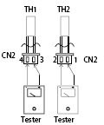
TH1: indoor room temperature sensor and outside air temperature sensor
TH2: indoor exchange temperature sensor and outside exchange temperature sensor
TH4: Outdoor exchange temperature sensor and outside exchange temperature sensor
TH5: Outdoor ambient temperature sensor and outside exchange temperature sensor
Before measuring resistance, disconnect connectors as shown above.
- Outdoor unit discharge sensor temperature characteristics
TEMP.  (℃) | R min  (k Ohm) | R(t)  (k Ohm) | R max  (k Ohm) | TEMP.  (℃) | R min  (k Ohm) | R(t)  (k Ohm) | R max  (k Ohm) | TEMP.  (℃) | R min  (k Ohm) | R(t)  (k Ohm) | R max  (k Ohm)
-30 | 288.879 | 337.780 | 386.68 | 23 | 20.114 | 21.847 | 23.579 | 76 | 2.733 | 2.835 | 2.937
-29 | 272.641 | 318.219 | 263.797 | 24 | 19.263 | 20.900 | 22.538 | 77 | 2.646 | 2.742 | 2.839
-28 | 257.401 | 299.897 | 342.392 | 25 | 18.453 | 20.000 | 21.547 | 78 | 2.561 | 2.653 | 2.745
-27 | 243.09*2 | 282.727 | 322.363 | 26 | 17.681 | 19.143 | 20.605 | 79 | 2.480 | 2.567 | 2.654
-26 | 299.654 | 266.633 | 303.613 | 27 | 16.945 | 18.327 | 19.710 | 80 | 2.401 | 2.484 | 2.567
-25 | 217.028 | 251.541 | 286.054 | 28 | 16.243 | 17.551 | 18.858 | 81 | 2.326 | 2.404 | 2.483
-24 | 205.162 | 237.383 | 269.604 | 29 | 15.575 | 16.811 | 18.047 | 82 | 2.183 | 2.253 | 2.324
-23 | 194.005 | 224.097 | 254.188 | 30 | 14.937 | 16.106 | 17.275 | 83 | 2.183 | 2.253 | 2.324
-22 | 183.513 | 211.625 | 239.736 | 31 | 14.328 | 15.434 | 16.541 | 84 | 2.115 | 2.182 | 2.249
-21 | 173.642 | 199.912 | 226.181 | 32 | 13.748 | 14.794 | 15.841 | 85 | 2.050 | 2.113 | 2.176
-20 | 164.353 | 188.909 | 213.465 | 33 | 13.194 | 14.184 | 15.175 | 86 | 1.984 | 2.047 | 2.109
-19 | 155.608 | 178.569 | 201.530 | 34 | 12.665 | 13.602 | 14.540 | 87 | 1.921 | 1.983 | 2.045
-18 | 147.373 | 168.850 | 190.326 | 35 | 12.160 | 13.048 | 13.935 | 88 | 1.860 | 1.921 | 1.982
-17 | 139.616 | 159.710 | 179.803 | 36 | 11.678 | 12.518 | 13.358 | 89 | 1.801 | 1.862 | 1.922
-16 | 132.307 | 151.112 | 169.917 | 37 | 11.217 | 12.013 | 12.809 | 90 | 1.744 | 1.804 | 1.864
-15 | 125.417 | 143.022 | 160.627 | 38 | 10.777 | 11.531 | 12.248 | 91 | 1.690 | 1.749 | 1.808
-14 | 118.921 | 135.407 | 151.893 | 39 | 10.357 | 11.071 | 11.784 | 92 | 1.637 | 1.695 | 1.754
-13 | 112.794 | 128.236 | 143.679 | 40 | 9.955 | 10.631 | 11.307 | 93 | 1.586 | 1.644 | 1.701
-12 | 107.014 | 121.483 | 135.952 | 41 | 9.571 | 10.211 | 10.852 | 94 | 1.537 | 1.594 | 1.651
-11 | 101.559 | 115.120 | 128.680 | 42 | 9.203 | 9.810 | 10.417 | 95 | 1.490 | 1.546 | 1.602
-10 | 96.410 | 109.123 | 121.836 | 43 | 8.852 | 9.427 | 10.002 | 96 | 1.444 | 1.500 | 1.555
-9 | 91.548 | 103.469 | 115.391 | 44 | 8.516 | 9.061 | 9.606 | 97 | 1.400 | 1.455 | 1.509
-8 | 86.956 | 98.138 | 109.320 | 45 | 8.194 | 8.711 | 9.228 | 98 | 1.358 | 1.412 | 1.465
-7 | 82.617 | 93.108 | 103.600 | 46 | 7.886 | 8.376 | 8.866 | 99 | 1.317 | 1.370 | 1.423
-6 | 78.516 | 88.362 | 98.209 | 47 | 7.591 | 8.056 | 8.520 | 100 | 1.277 | 1.329 | 1.382
-5 | 74.640 | 83.883 | 93.126 | 48 | 7.309 | 7.750 | 8.190 | 101 | 1.239 | 1.290 | 1.342
-4 | 70.974 | 79.653 | 88.332 | 49 | 7.039 | 7.750 | 8.190 | 102 | 1.202 | 1.253 | 1.303
-3 | 67.507 | 75.659 | 83.810 | 50 | 6.780 | 7.176 | 7.572 | 103 | 1.166 | 1.216 | 1.266
-2 | 64.227 | 71.885 | 79.543 | 51 | 6.532 | 6.908 | 7.283 | 104 | 1.132 | 1.181 | 1.230
-1 | 61.123 | 68.319 | 75.515 | 52 | 6.294 | 6.650 | 7.007 | 105 | 1.099 | 1.147 | 1.195
0 | 58.184 | 64.948 | 71.712 | 53 | 6.066 | 6.404 | 6.743 | 106 | 1.066 | 1.114 | 1.162
1 | 55.402 | 61.761 | 68.120 | 54 | 5.847 | 6.168 | 6.489 | 107 | 1.035 | 1.082 | 1.129
2 | 52.766 | 58.746 | 64.726 | 55 | 5.638 | 5.942 | 6.247 | 108 | 1.005 | 1.051 | 1.098
3 | 50.269 | 55.894 | 61.519 | 56 | 5.437 | 5.726 | 6.015 | 109 | 0.976 | 1.022 | 1.067
4 | 47.903 | 53.195 | 58.488 | 57 | 5.244 | 5.518 | 5.793 | 110 | 0.948 | 0.993 | 1.038
5 | 45.661 | 50.641 | 55.621 | 58 | 5.059 | 5.319 | 5.580 | 111 | 0.921 | 0.965 | 1.009
6 | 43.543 | 48.222 | 52.910 | 59 | 4.882 | 5.129 | 5.376 | 112 | 0.895 | 0.938 | 0.981
7 | 41.517 | 45.931 | 50.345 | 60 | 4.711 | 4.946 | 5.180 | 113 | 0.869 | 0.912 | 0.955
8 | 39.604 | 43.761 | 47.917 | 61 | 4.548 | 4.770 | 4.993 | 114 | 0.845 | 0.887 | 0.929
9 | 37.789 | 41.704 | 45.619 | 62 | 4.39 | 4.602 | 4.813 | 115 | 0.821 | 0.862 | 0.904
10 | 36.066 | 39.755 | 43.443 | 63 | 4.240 | 4.440 | 4.641 | 116 | 0.798 | 0.839 | 0.879
11 | 34.431 | 37.907 | 41.383 | 64 | 4.094 | 4.285 | 4.475 | 117 | 0.776 | 0.816 | 0.856
12 | 32.787 | 36.154 | 39.430 | 65 | 3.955 | 4.136 | 4.317 | 118 | 0.754 | 0.794 | 0.833
13 | 31.403 | 34.491 | 37.580 | 66 | 3.821 | 3.993 | 4.164 | 119 | 0.733 | 0.772 | 0.811
14 | 30.001 | 32.914 | 35.826 | 67 | 3.693 | 3.855 | 4.018 | 120 | 0.713 | 0.751 | 0.789
15 | 28.670 | 31.417 | 34.163 | 68 | 3.569 | 3.723 | 3.878 | 121 | 0.694 | 0.731 | 0.769
16 | 27.404 | 29.995 | 32.586 | 69 | 3.450 | 3.596 | 3.743 | 122 | 0.675 | 0.712 | 0.749
17 | 26.200 | 28.645 | 31.090 | 70 | 3.335 | 3.475 | 3.614 | 123 | 0.657 | 0.693 | 0.729
18 | 25.056 | 27.363 | 29.671 | 71 | 3.225 | 3.357 | 3.490 | 124 | 0.639 | 0.675 | 0.710
19 | 23.967 | 26.145 | 28.324 | 72 | 3.119 | 3.245 | 3.370 | 125 | 0.622 | 0.657 | 0.692
20 | 22.931 | 24.988 | 27.044 | 73 | 3.017 | 3.136 | 3.225
21 | 21.946 | 23.888 | 25.830 | 74 | 2.919 | 3.032 | 3.145
22 | 21.007 | 22.842 | 24.676 | 75 | 2.824 | 2.932 | 3.093

R—Resistance
Resistance at 25℃:20 kΩ
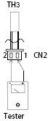
TH3: Outdoor unit discharge pipe sensor
Before measuring resistance, disconnect connectors as shown above.

